Judaism

Name
Institution
Course
Professor
Date

Judaism
This paper will identify and speak Judaism-based wondering, and the way the historical past of Jewish historical past builds Jewish confidence. Judaism is the sector's maximum installed religion, traces back to almost four thousand years. The Jews accept that there's only one God of the arena who has been taught to them and discovered through the historical prophets. The historic background of Judaism is essential in understanding Jewish self-confidence, that's why this paper explores the involvement of scientists with the Museum (Florida-FIU). Florida's Jewish Museum, based in 1995, is a large exhibition Conner dedicated to narrating Jewish records. This paper will display that Jewish records play an essential position in shaping their self-belief. this may be invested in a comprehensive collection of antiquities, documents, pix and oral texts. additionally, this paper may even talk about how Judah-based thinking is based totally on such fundamental ideas as the worship of one creator, and the agreement, and will show this by using combining its exam of a non-secular set of experiences, and how its ideals continue to be strong over one thousand years.
Judaism has suffered for decades as a strong faith due to the fact adherence to sure fundamental ideals. The Jews receive that there's simplest one God who created the universe without assist, but each Jew has a private relationship with every other. The Jewish humans sense that God is wearing on his work within the world of human affairs. First, Judaism is a monotheistic faith, which means that that they accept that there may be most effective one God who does all things. This notion is confirmed via the scriptures among the Torah/Jewish regulation, which carries 5 books regarding the entirety especially the non-Jews as the "Hebrew Scriptures". Torah is sacred for the Jews as it interestingly gives the simple rules and precepts of Judaism. (AICE 2010) then again, the Talmud, which means "reading" in Hebrew, is a spread of operations that encompass a whole listing of Jewish regulation and customs, compiled, together with translated in between the number three and 6th centuries. (Shurpin 2016) Jewish humans love the heavenly places that are called temples, and their innermost chieftains are well known as rabbis. For the six-point, David’s megastar is a symbol of Judaism. these days, there are approximately fourteen million Jews globally. All-out of them are living in the U.S and the whole of Israel. Traditionally, someone is considered a Jew if his mom is Jewish. (Onions 2018)
Moreover, the Jewish interacting with the Almighty God is a pledge. Just like shown in Judaism, a pledge is a guarantee that Abraham had with God while God could deliver welfare and terrestrial to Abraham and his spouse and children, and but, as a result, they should follow God's way below the terms of the agreement, Israel’s land became given to the Jewish humans via the prophet Moses on Sinai Mountain as an example, this pledge changed into made utilizing persevering with to coach Abraham and his human beings privileged the future to undergo the art of circumcision (brit milah). Certainly, even nowadays, the Jewish community goes beyond circumcision as a manner of seeking out assurance. Jewish subculture stems from the Abrahamic covenant with God, which makes Abraham's faith similar to Christianity and the whole of Islam. For the reason that Jews relating with God is like a given covenant, the transaction of all that God has ended and keeps to accomplish for all the humans, the Jews hold the commandments of God and are searching for to carry holiness to every element in their lives. further, collateral could have distinct consequences on different people depending on their distribution, beliefs, practices, and lifestyle
Some other robust perception in Judaism is that Judah culture is a nearby faith. All the Jews believe that God has chosen the Jews to be His selected human beings to make a photograph of happiness and morality inside the world. (BBC 2009) The day-by-day Jewish method relies upon a feeling of location as an area and there are numerous exams they have to do properly. Many sturdy Jewish traditions surrounded the homes of those with Judah culture. One example is a Sabbath dinner where families would be part of; the reception on an unusual day. (BBC 2009)
Other than supporting their self-self-assurance in other critical beliefs, the self-assurance of the Jews is greatly affected and formed through their revel. I have seen and investigated this by continuing to go to the Jewish Museum of Florida-FIU. Florida's Jewish Museum is a first-rate historic middle committed to documenting Jewish history in Florida in terms of language and tradition, with a revolutionary series of greater than 100,000 items. The Museum is housed in two restored systems that served because the web page for the first Jewish meeting in Miami beach. The exhibition corridor is accepted by way of the Yankee Alliance of Museums and has executed a system of value in its examination, writing, series, protection, expertise, and interpretation of its artifacts. (FIU 2012)
The demonstration hall makes the knowledge brilliant and also makes you familiar with the experience of Jews like workers in our multiethnic culture that is in the states of Miami and that of Florida. This museum showing center, MOSAIC which is the Jewish kind of life in Florida 1763 to date, started by Marcia Jo Zerivitz, started as a collection of statues, antiques, and spoken stories originating from the genealogy of developer families, as well as later. Mosaic produced so much attention that in 1995, it was transformed into the Florida Museum. (FIU 2012)
Looking deeply into this exhibition hall made me realize that the past of Judaism is crucial to understanding Jew-related self-confidence which is a great cultural heritage, law, and tradition. The motive of this gallery center is to further promote and support resistance, the continuation of the international agreement, and the formation of relations with Jewish culture, history, discourses, and traditions. The galleries of the gallery focused on his people and continued to affect the development of Jewish self-confidence in the country. "In particular, although the zeros exhibition hall in its Jewish religious development experience in Miami Beach, has found how it will vividly articulate the history of Judaism and how Jews come together as local to their self-confidence and conviction. Photos and oral accounts can be very enlightening, informative, and very deep. In line with their exciting ever-changing exhibitions, studios, family experiments, lectures, and presentations. (FIU 2012)
The paper found that the experience played a major and fundamental role in Judaism and in building the confidence of religious adherents. Following the demolition of ancient archives, archives, photographs, and oral archives from the Jewish Museum in Florida this writing had the opportunity to show that the impression of ​​focusing on Judaism was established through already recognized beliefs, for example, Monotheism, Agreement (understanding between God and his relatives), sacred texts of the Torah and the Talmud. This writing proves the understanding of Jewish self-confidence and the personal principles that should be taught through the experience they have.
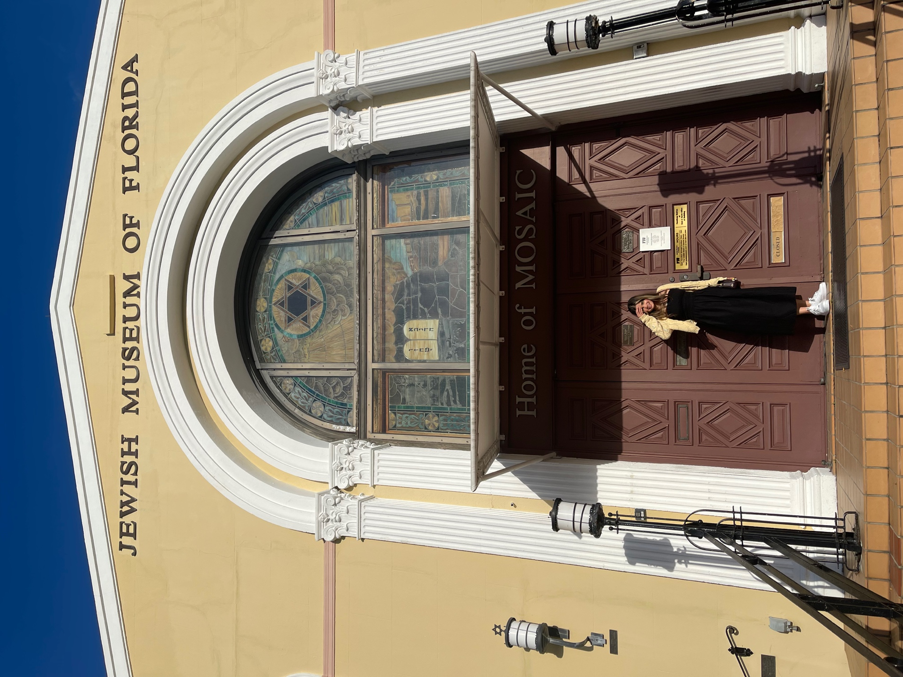

Works Cited
AICE. 2010. Jewish Virtual Library. Accessed October 5, 2021. https://www.jewishvirtuallibrary.org/the-written-law-torah.
BBC. 2009. BBC. September 14. Accessed October 5, 2021. https://www.bbc.co.uk/religion/religions/judaism/beliefs/beliefs_1.shtml.
FIU. 2012. JMOF FIU. Accessed October 5, 2021. https://jmof.fiu.edu/about/index.html.
Onion, Amanda. 2018. HISTORY. January 5. Accessed October 8, 2021. https://www.history.com/topics/religion/judaism.
Shurpin, Yehuda. 2016. Chabad Org. Accessed October 5, 2021. https://www.chabad.org/library/article_cdo/aid/3347866/jewish/What-Is-the-Talmud-Definition-and-Comprehensive-Guide.htm.

AICE, “Judaism” Shurpin, “Talmud” Onion, “Today”
BBC, “Jews believe” BBC, “Many Jewish religious customs” FIU, “The Jewish Museum of Florida” FIU, “MOSAIC”

